Aerosol Jetting module:

Optomec Print Engine (AJ 5X System, Optomec Inc., Albuquerque, New Mexico, USA) with a pneumatic atomizer (https://optomec.com/ajprintengine/)

Photonic curing module (UV Lamp)

Xenon flash lamp (model RC-847, Xenon Corp., USA) (https://www.excelitas.com/product-category/flashlamps)

FFF Extrusion module

Prusa3D (Prague, Czech Republic) (<https://www.prusa3d.com/>) did not find printhead, think any other companies will work.

Maybe makergear (<https://makergear.com/collections/parts/products/extruder-motor?variant=21668418500>)

DIW Extrusion module

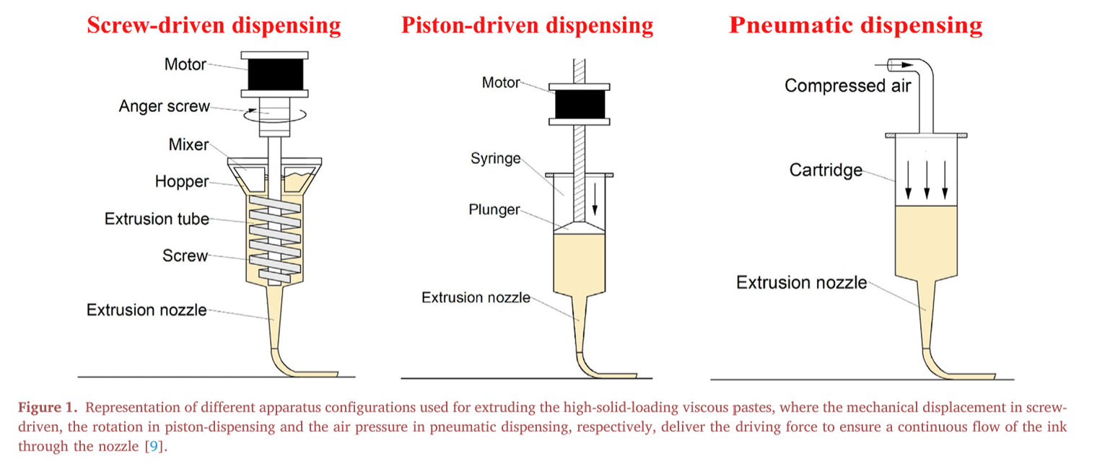

Pneumatic control

1. precision pneumatic pressure regulator (UltimusV, Nordson EFD, East Providence, RI, USA)

The syringes are mounted in metal sleeves with embedded heaters

(https://www.nordson.com/en/products/efd-products/ultimus-v-dispensers)

1. Pressure sensor, solenoid valve, MOSFET

Piston extrusion

Motorized ball screw actuators

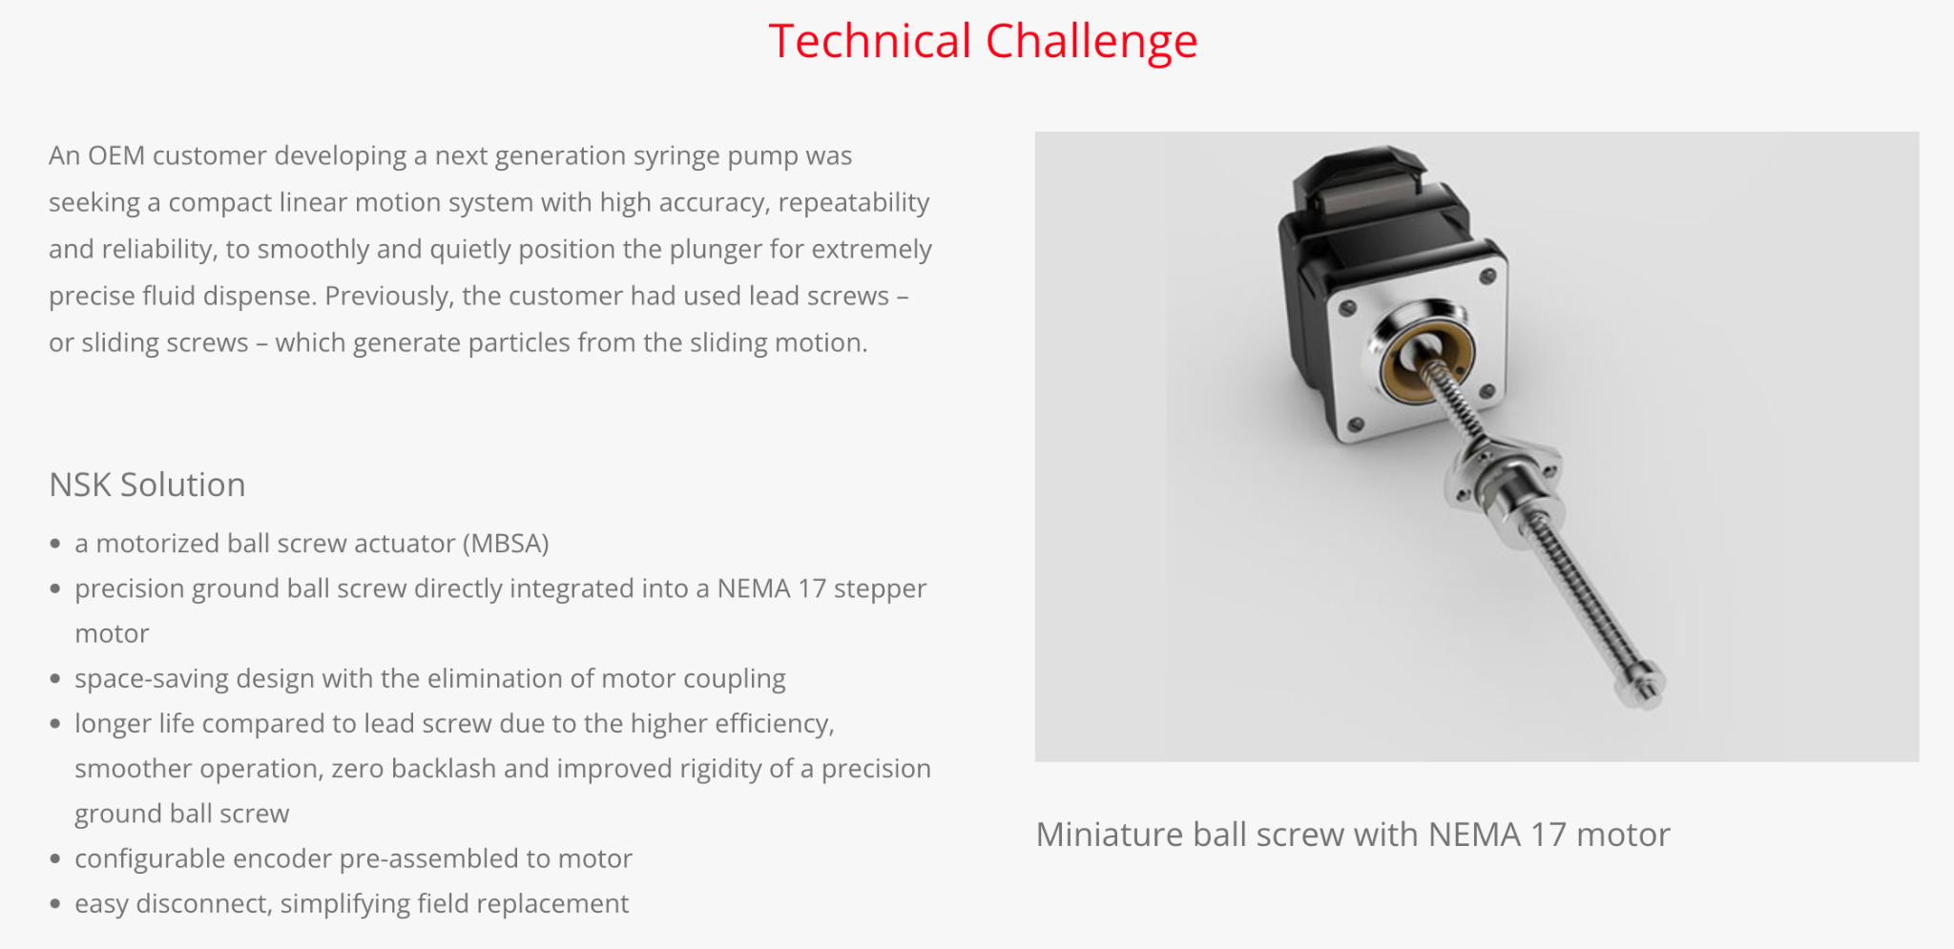

Inkjet module

Xaar 1003 (Xaar Plc, United Kingdom) piezoelectric drop-on-demand printheads (https://www.xaar.com/en/products/xaar-printheads/xaar-1003-c/)

FE300 LED UV lamp (Phoseon, Hillsboro, OR) (https://phoseon.com/industrial-curing/)

Hydra ink supply system from Xaar

(https://www.xaar.com/en/products/systems-components/xaar-hydra-ink-supply-system/)

Electrical control

All motions involved in the printing process are controlled by either the dedicated Aerotech A3200 motion controller or the robotic controller.

To synchronize the motion stages, material deposition, and robot motion, an in-house software coded in Python was developed for the m4 3D printer.

The motion commands for the six linear motion stages are supplied via traditional G- code

Coordinate Transformations

Each technique has its own unique communication language and independent coordinate system.

Extrusion based single nozzle 3D printing techniques (such as FFF and DIW) typically rely on G-code, a point-to-point printing scheme, whose toolpath is generated from cross-sectional slices of a solid model.

Inkjet 3D printing prints a single layer in a few discrete movements by utilizing an array of piezoelectric nozzles to deposit build material. Bitmap images are typically used to represent a single layer of the designed part and are thus printed accordingly.

Control Software

The work-flow was coded into Python and a user-friendly user interface (UI) printer software was developed to assist users

Other parts might need

Hot plate

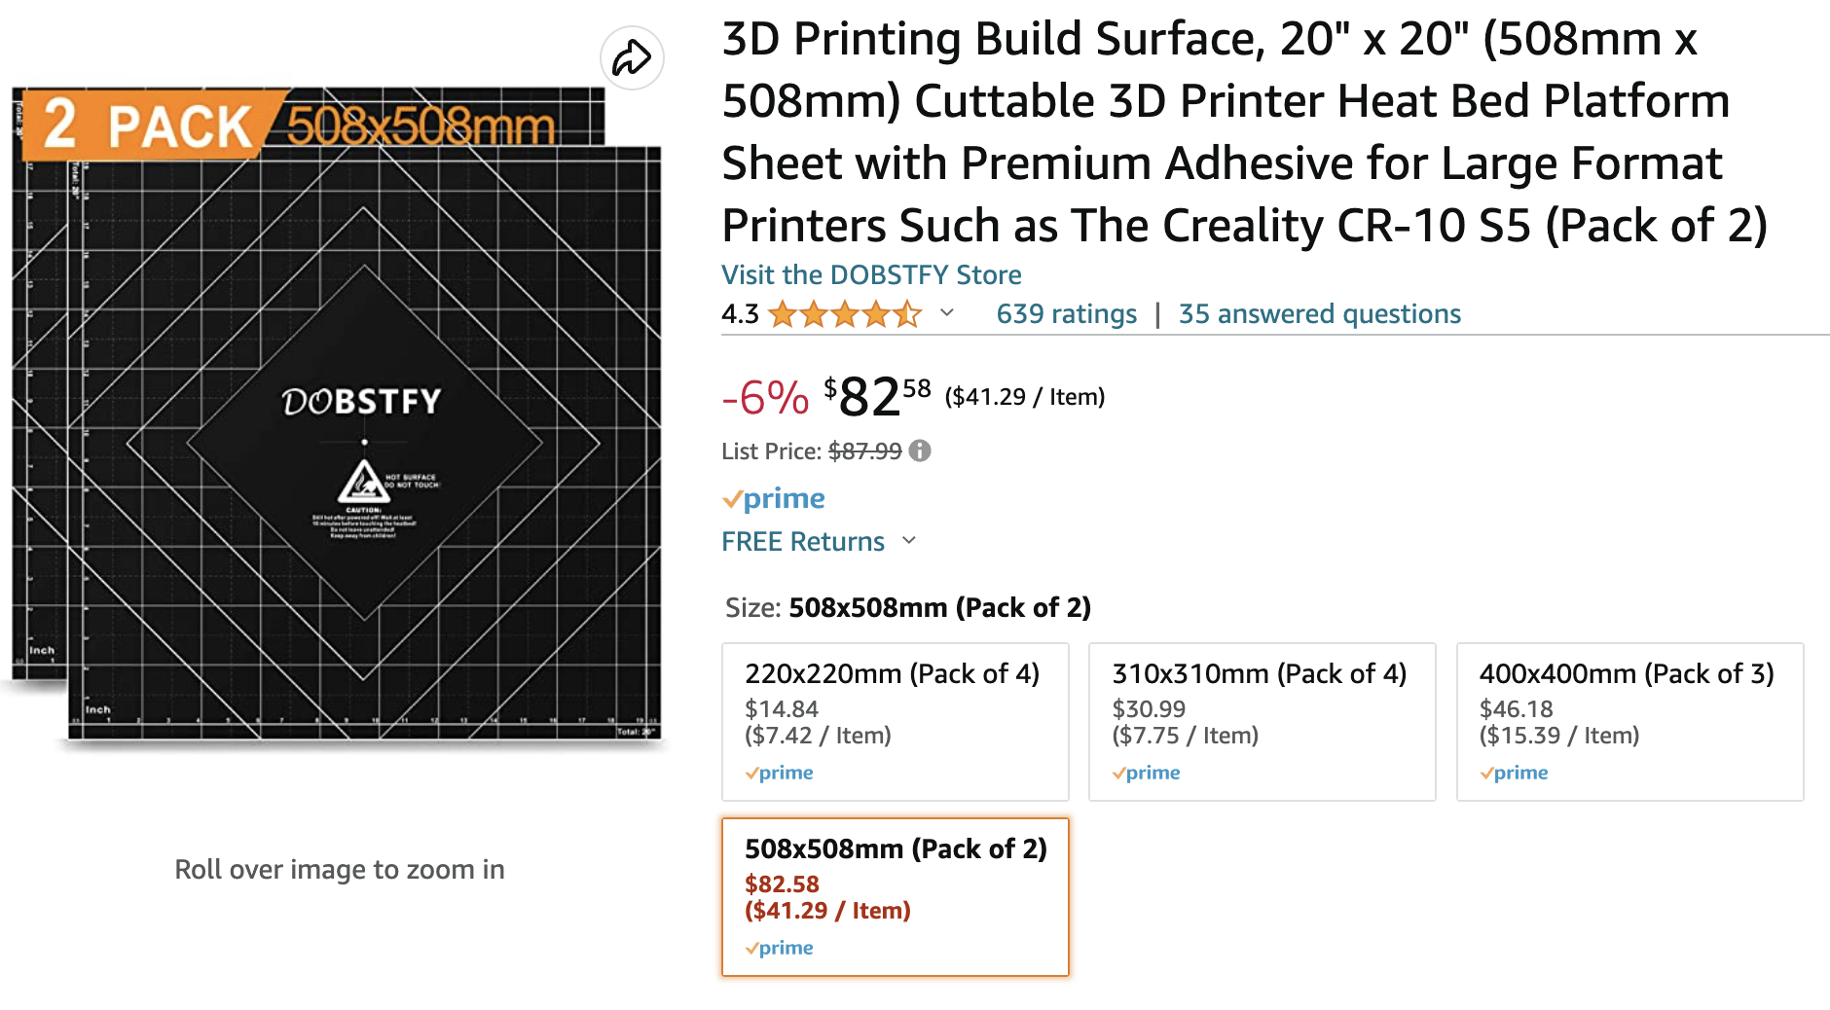

Normal plate

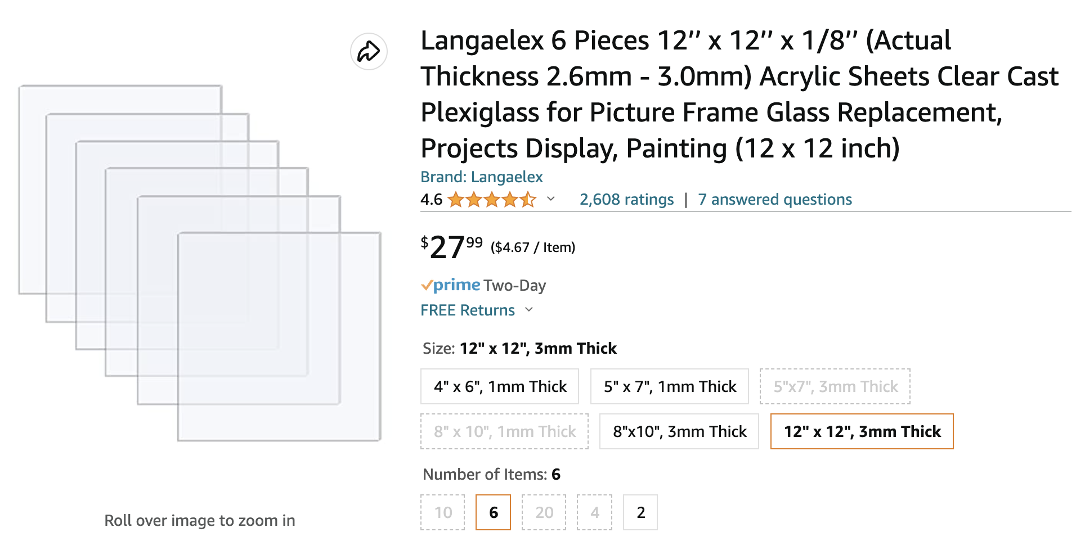

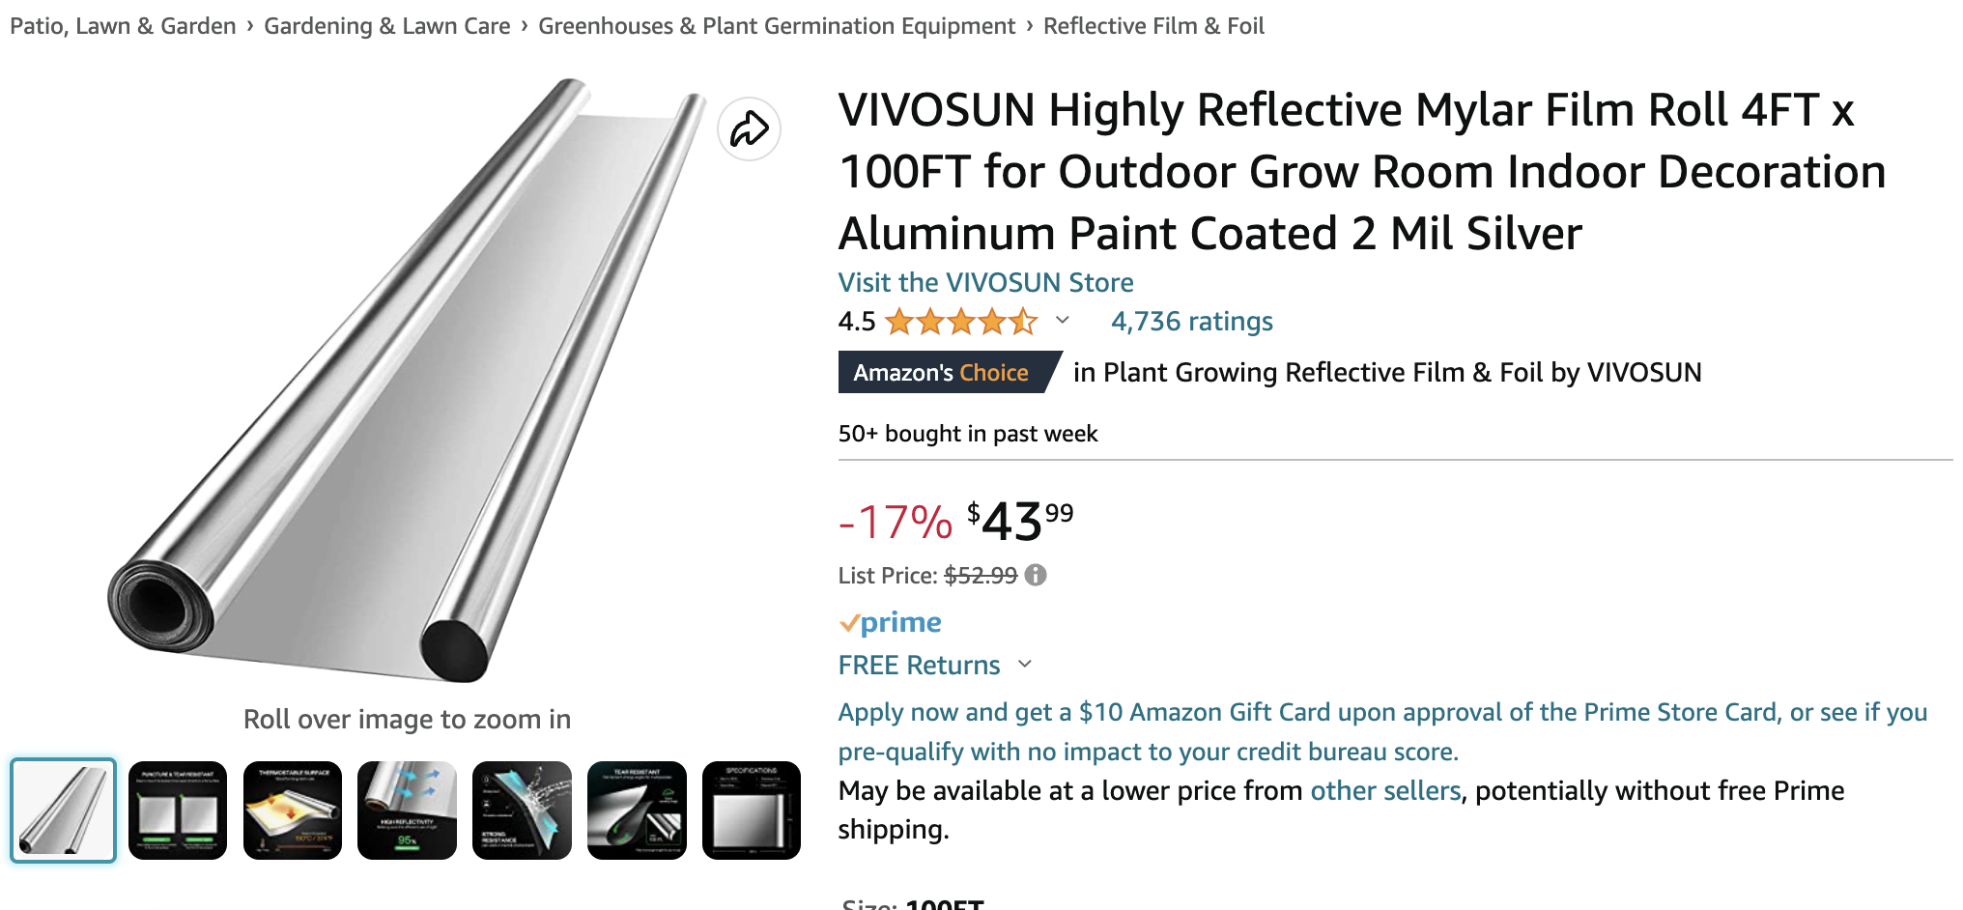

Heating extruder

Magentic coil

Heating coil

syringe holder

Laser generator and recognizer (calibrate offset)

Material

Soft elastomer resin (DIW)

silver nanoparticle-based conductive ink (conductive ink)

photocurable acrylate-based polymer (inkjet)

ABS material(FFF),